Math 10C Review
To be completed before starting Math 20-1

1. Identify the error in each of the following and show a correct solution.

a. $\frac{1}{2}+\frac{2}{3 }= \frac{3}{6}+\frac{4}{6}$ b. $-5\frac{1}{4}+2\frac{1}{8}= -\frac{19}{4}+\frac{17}{8}$

$=\frac{3+4}{6+6}$ $=-\frac{38}{8}+ \frac{17}{8}$

$= \frac{7}{12}$ $=-\frac{21}{8}$

2. Add or subtract the following fractions by getting a common denominator. Show all steps of work. Express all answers in simplest improper form.

a. $\frac{2}{3}+\frac{4}{5}$ b. $\frac{1}{2}-\frac{1}{3}$ c. $3\frac{2}{3}+2\frac{1}{2}$

d. $\frac{5}{12}- \frac{1}{3}$ e. $5\frac{1}{4} -2\frac{5}{6}$ f. $\frac{3}{8}+\frac{3}{4}-\frac{5}{6}$

g. $\frac{4}{5}-\frac{2}{3}+\frac{1}{4}$ h. $6- \frac{2}{3}$ i. $\frac{9}{5}-1$

3. Multiply or divide the following fractions. Express in simplest improper form.

a. $\frac{2}{7}×\frac{3}{4}$ b. $\left(\frac{1}{5}\right)\left(\frac{12}{13}\right)$ c. $\left(\frac{3}{8}\right)\left(\frac{4}{5}\right)$

d. $\left(2\frac{1}{6}\right)\left(\frac{3}{5}\right)$ e. $\left(1\frac{1}{4}\right)\left(5\frac{2}{3}\right)$ f. $\left(-1\frac{5}{7}\right)\left(-2\frac{1}{2}\right)$

g. $\frac{3}{4}÷\frac{1}{2}$ h. $\frac{3}{8}÷\frac{4}{5}$ i. $-\frac{5}{6}÷\frac{3}{4}$

j. $3\frac{1}{8}÷\frac{3}{4}$ k. $-2\frac{1}{2}÷1\frac{5}{6}$ l. $3\frac{1}{4}÷\frac{-1}{ 2}$

4. Convert the following radicals to simplest mixed radical form.

a. $\sqrt{50}$ b. $\sqrt{12}$ c. $\sqrt{60}$

d. $4\sqrt{45}$ e. $\sqrt{21}$ f. $2\sqrt{48}$
g. $\sqrt[3]{32}$ h. $5\sqrt[3]{250}$ i. $6\sqrt[3]{108}$

j. $\sqrt{99x^{3}}$ k. $\sqrt{600a}$ l. $\sqrt[3]{162}$

m. 2 $\sqrt{20}$ n. -1$\sqrt[3]{16}$ o. $\sqrt{700x^{2}y}$

5. Complete the following chart by converting between radical and exponential form.
Radical Form | Exponent Form
$$\sqrt[5]{3^{2}}$$

 | $$x^{\frac{1}{2}}$$
$${5\sqrt{ac}}^{3}$$

 | $${\left(xy\right)}^{\frac{3}{4}}$$
$$\sqrt[3]{6}$$

 | $$4y^{\frac{3}{2}}$$

6. Fully simplify the following exponential expressions using the laws of exponents. Express final answers using positive exponents only.

a. $(3xy)(4x^{5}y^{2})$ b. ${\left(\frac{p^{-7}q^{2}}{p^{2}q^{-8}}\right)}^{2}$ c. ${\left(a^{-2}b\right)}^{-3}\left(ab^{-7}\right)$

d. ${\left(\frac{-6u^{-5}v^{2}}{-2u^{4}v^{3}}\right)}^{2}$ e. $\left(-8m^{-3}n^{2}\right){\left(2m^{5}n\right)}^{3}$ f. ${\left(\frac{-9mn^{-3}}{3m^{4}n^{-5}}\right)}^{2}$

g. $\frac{(5r^{-2})(2r^{-6})}{7r^{5}}$ h. $\left(\frac{-3x^{2}y^{3}}{x^{-4}y^{2}}\right)\left(-2x^{-8}y^{-2}\right)$ i. ${\left(s^{4}t^{2}\right)}^{3}{\left(s^{-5}t^{3}\right)}^{2}$

j. $\dot{\left(-8r^{3}s^{-5}\right)\left(\frac{r^{7}s^{-5}}{2r^{-4}s^{7}}\right)}$ k. ${\left(\frac{-4b^{-2}c^{3}}{-8b^{4}c^{-7}}\right)}^{-3}$ l. $\left(-5a^{2}b^{4}\right){\left(2bc^{-3}\right)}^{2}{\left(-3c^{4}\right)}^{3}$

7. These problems have some of the most common mistakes that students make with exponents. Three of these problems are correct. Circle the correct ones & explain and correct the mistake in the ones with errors.

a) (x³y⁴)(x³y⁴) = 2x³y⁴ b) (3m³)(2m⁵) = 5m⁸ c) (6a³b)(2a³b⁴) = 12a⁶b⁴

d) (4p²q⁴)(p²q) = 4p⁴q⁵ e) (5f³)(7f⁵) = 35f¹⁵ f) (x³y)² = x⁵y²

g) (m²)³ = $m^{2^{3}}$= m⁸ h) (3m³)³ = 27m⁹ i) (4g²)(g⁵) = 16g⁵

j) (5x⁷y⁴)⁵ = 5x³⁵y²⁰ k) (3a⁴b²)³ = 9a¹²b⁶ l) (-m²n)(2m⁵n⁴) = m³n³

m) (-m²)(2m⁵n⁴) = 2m⁷n⁴ n) 3x(4x²y)² = (12x³y)² = 144x⁶y²

o) w⁴(3w² + 2w – 1) = 3w⁶ + 2w – 1 p) 5xy³(5x – y) = 25x²y³ – 5xy⁴

q) 3x²(x⁴ + 3x² + 2) = 3x⁶ + 9x⁴ + 6x² = 18x¹² r) 5a²b(3a² + 2b³) = 8a⁴b + 7ab⁴

8. Kristine was solving some linear equations. Her work is shown below. Each solution is incorrect . Identify the error & provide a correct solution.

a) b)
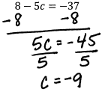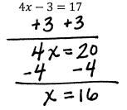

9. Solve the following equations algebraically. Show all your work.

a) -20 = -4x – 6x b) 6 = 1 – 2n + 5 c) 8x – 2 = -9 + 7x

d) a + 5 = -5a + 5 e) 4m – 4 = 4m f) p – 1 = 5p + 3p – 8

g) 5p – 14 = 8p + 4 h) p – 4 = -9 + p i) -8 = -(x + 4)

j) 12 = -4(-6x – 3) k) 14 = -(p – 8) l) -(7 – 4x) = 9

m) -18 – 6k = 6(1 + 3k) n) 5n + 34 = -2(1- 7n) o) 2(4x – 3) – 8 = 4 + 2x

p) 3n – 5 = -8(6 + 5n) q) -(1 + 7x) – 6(-7 – x) = 36 r) 24a – 22 = -4(1 – 6a)

s) -3(4x + 3) + 4(6x + 1) = 43 t) -5(1 – 5x) + 5(-8x – 2) = -4x – 8x

10. Completely factor the following polynomials.

a) 2x² + 3x – 9 b) 5x² + 19x + 12

c) 2w² + 7w + 5 d) 2p² + 11p + 5

e) 3v² – 8v + 4 f) 3x² – 2x - 5

g) 25n² – 1 h) 9m² + 66m + 21

i) 7q² + 53q + 28 j) 2x² – 18

k) 15n² – 27n – 6 l) 5r² – 18r + 9

m) 4n² – 15n – 25 n) 4c² – 35c + 49

o) 4x² – 17x + 4 p) 6y² + 7y – 49

q) 6k² + 37k + 6 r) -6m² – 25m - 25

11. Solve the following systems of equations algebraically by using either the elimination method or the substitution method.

a) y = -3x + 4 b) y = x + 2
y = 3x – 2 x = -3

c) x – y = 3 d) 4x + y = 2
7x – y = -3 x – y = 3

e) y = 4x – 9 f) 4x + 2y = 10
y = x – 3 x – y = 13

g) 6x + 8y = -22 h) -7x + 2y = 18
y = -5 6x + 6y = 0

i) -7x – 24 = -4y j) x + 7y = 0
4x = 4y 2x = 22 + 8y

k) 4x = 20 + y l) 20 + 8x = 6y
0 = 2x + 2y + 10 7y = 16x + 30

12. Mrs. Properzi was trying to solve the system of equations shown below by using the substitution method but she made an error. Find and correct her mistake.
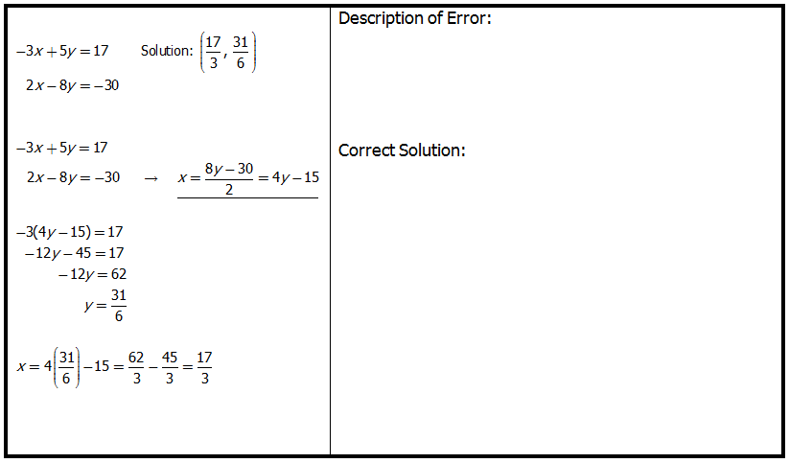

13. Katherine was solving the system of equations shown below but made a terrible mistake. Find & correct the error.
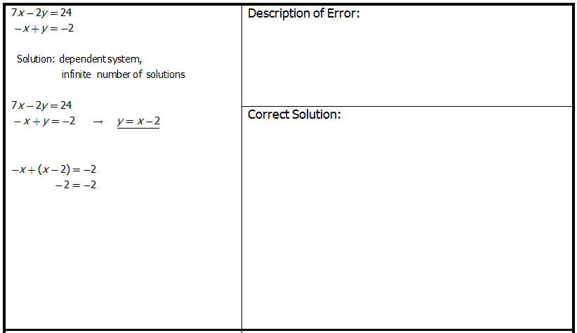

14. Solve the following triangles for all the unknown sides and angles. Round sides to the nearest tenth and angles to the nearest degree.

a) b)
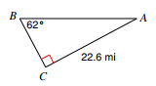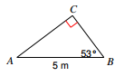

c) d)
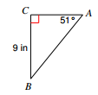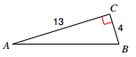

e) f)
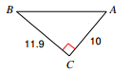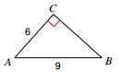

g) h)
