**Quadratic Formula:** 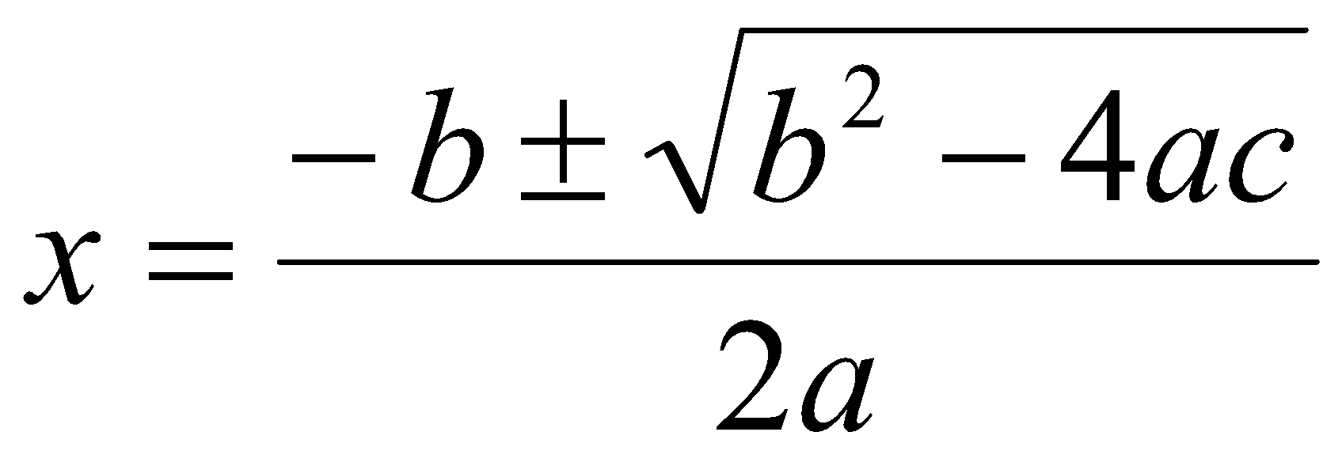

**Example:**

**x2 + 3x – 5 = 0 a =1 b = 3 c = -5**

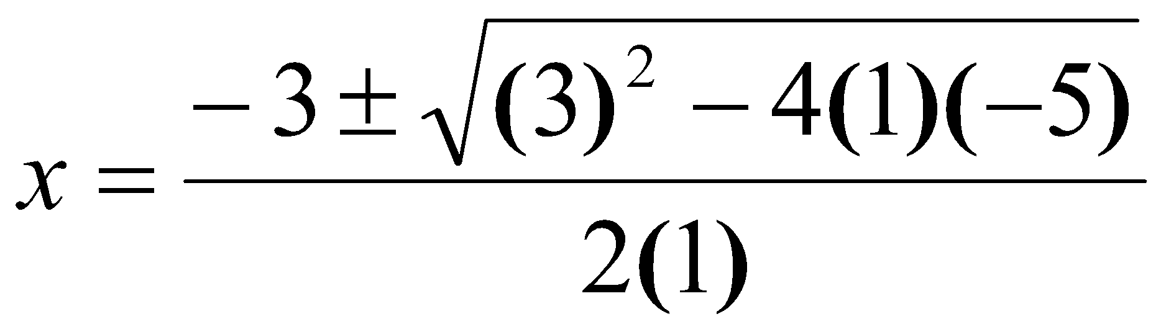

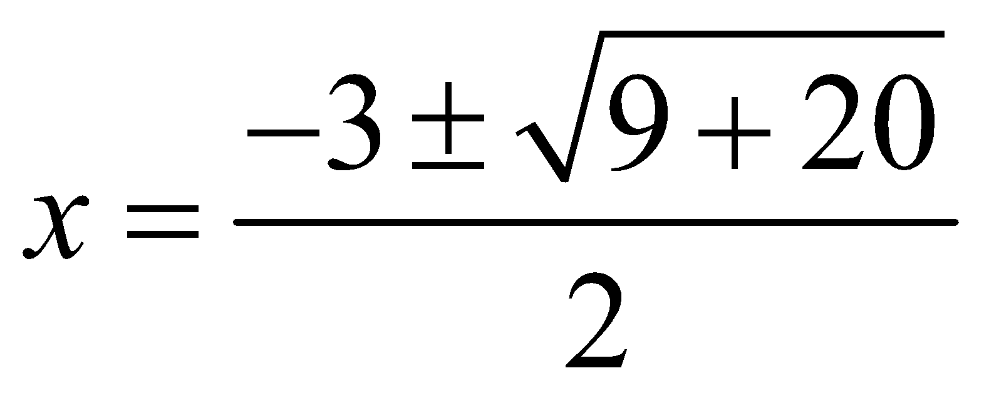

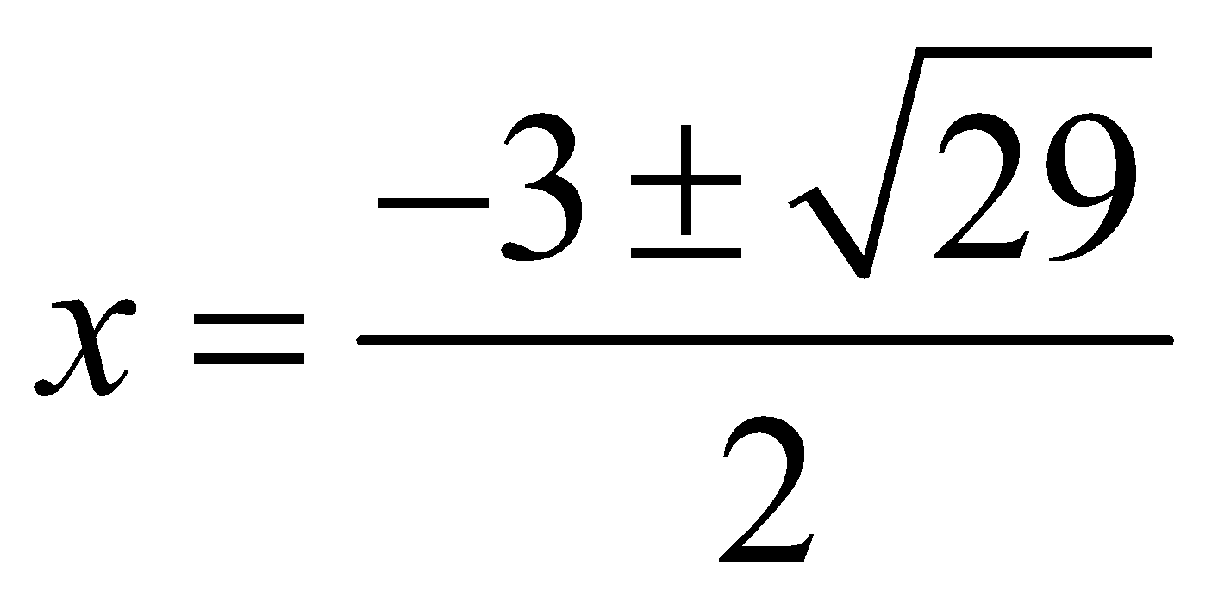

1. **Solve by using the quadratic formula.**

**6y2 – 5 = 3y 3r2 – r + 2 = 0**

1. **Solve by using the quadratic formula.**

**4x2 + x = x – 5**

# **Simplify Fractions in your solutions from the Quadratic Formula and express your answers as exact.**

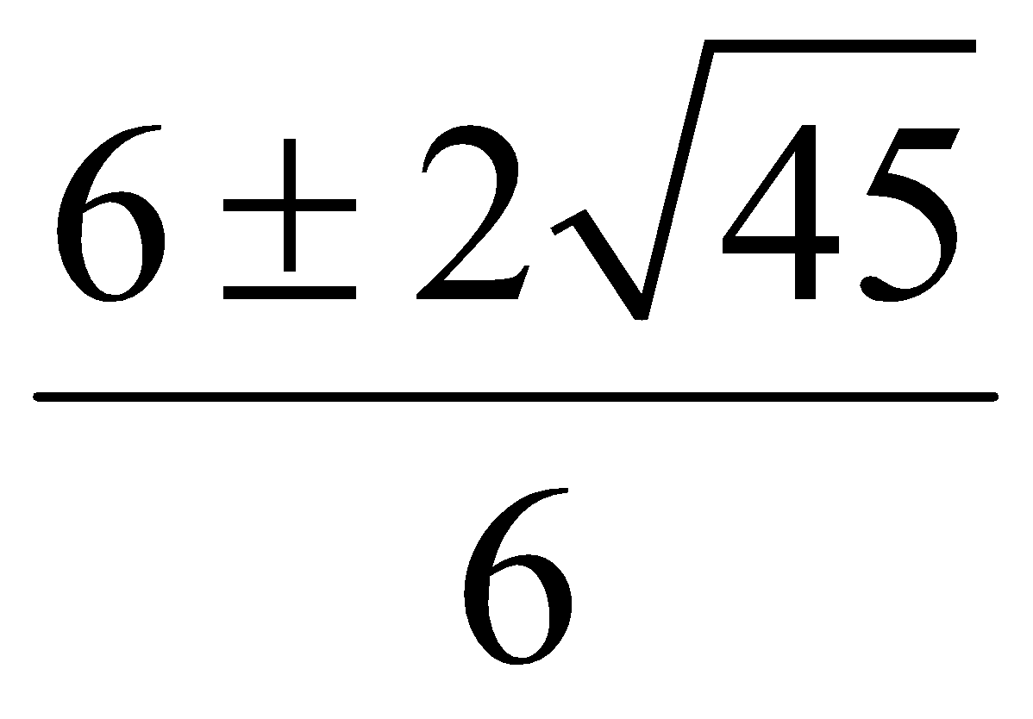 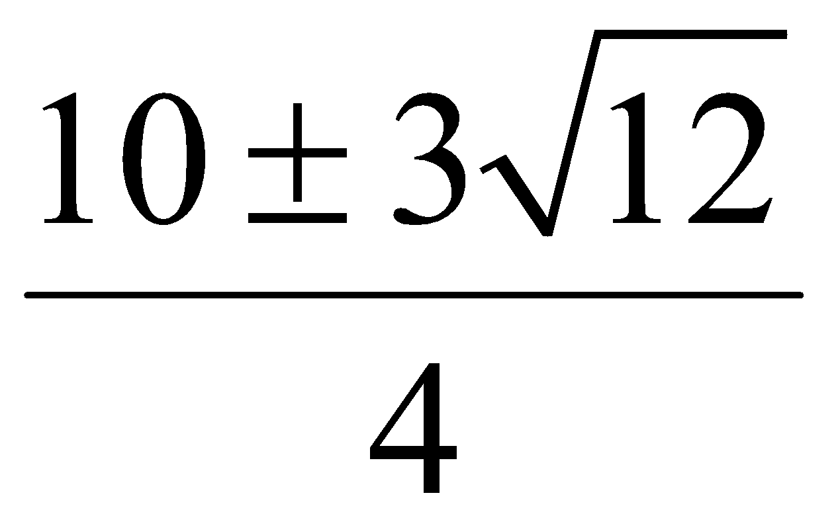 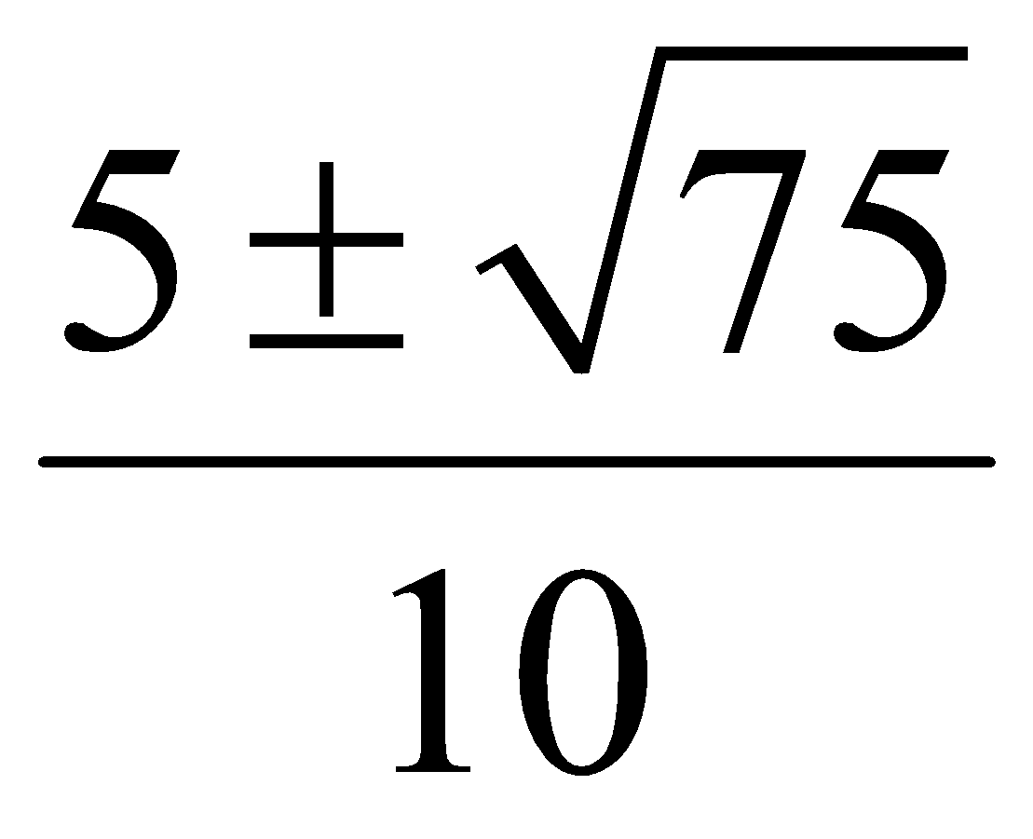

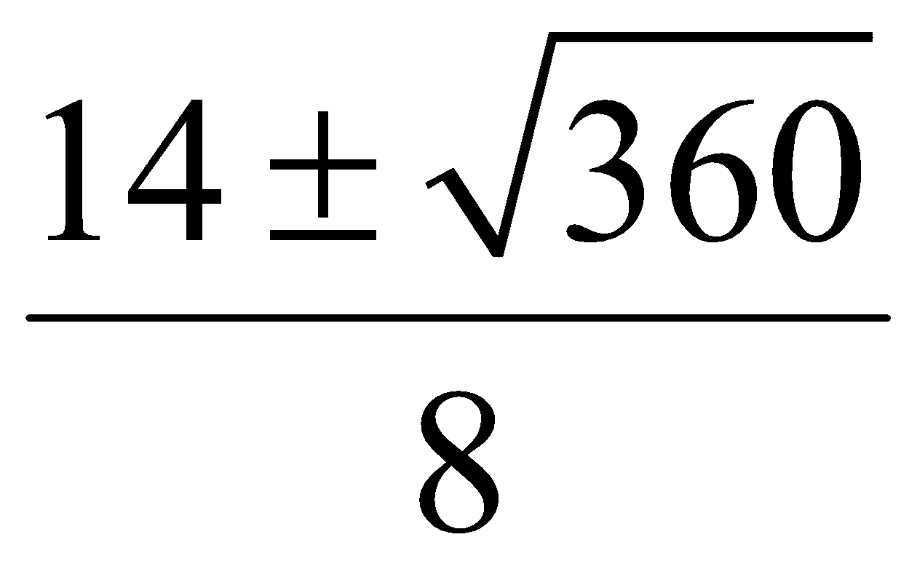 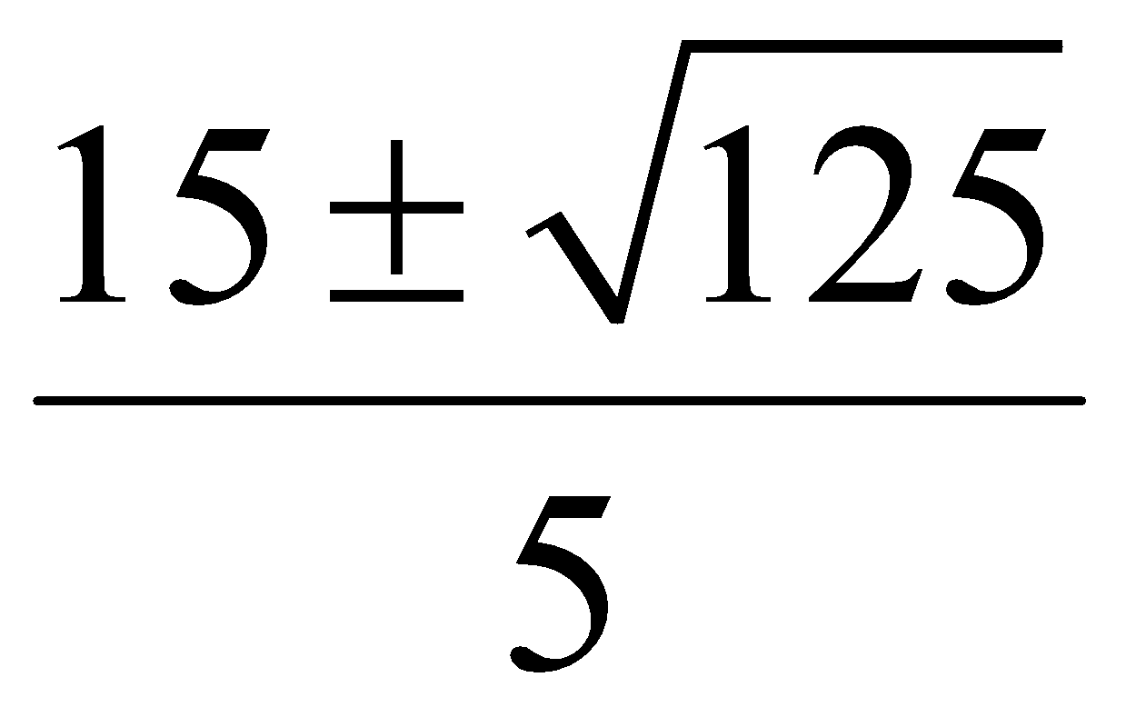 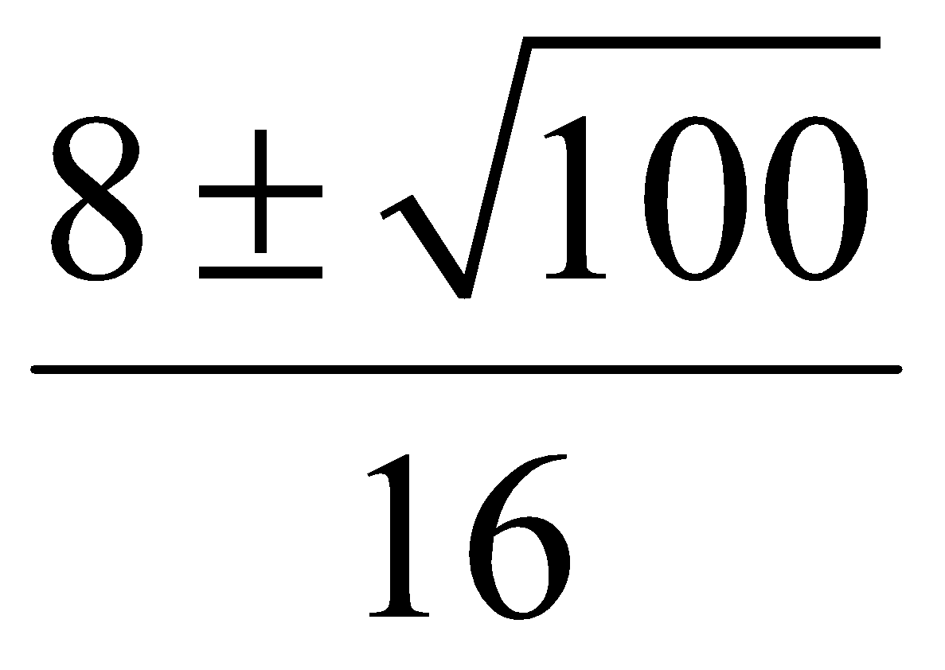

**CAST Rule and Trigonometry in the Coordinate Plane**

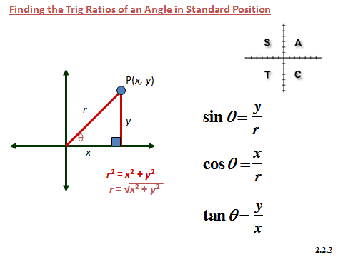

1. The coordinates of a point *P* on the terminal arm of each angle are shown. Write the exact trigonometric ratios sin θ, cos θ, and tan θ for each. **HINT:** Determine the value of ***r*** first.

1. b) 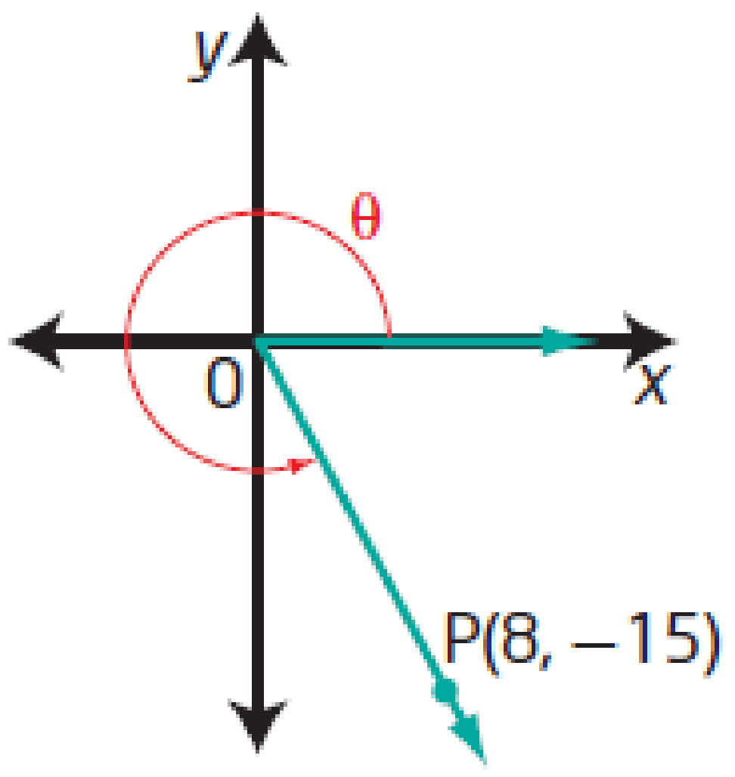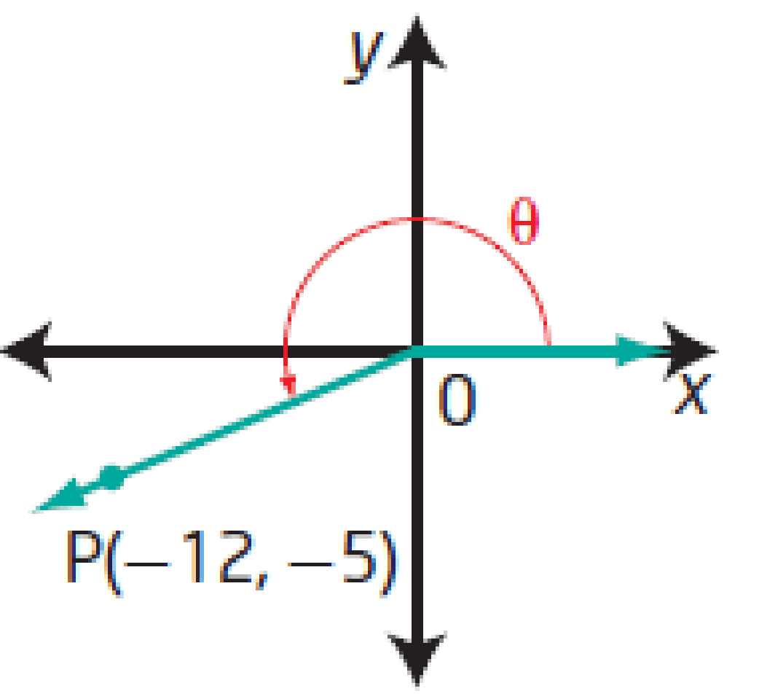

2. Without using a calculator, state whether each ratio is positive or negative. **HINT:** Use the CAST rule.

a) sin 155° b) cos 320°

c) tan 120° d) cos 220°

3. Determine the exact values of sin θ, cos θ, and tan θ if the terminal arm of an angle in standard position passes through the given point. **HINT:** Determine the value of ***r*** first.

a) P(−5, 3) b) P(6, 3)

4. Determine the values of *x*, *y*, *r*, sin θ, cos θ, and tan θ in each.

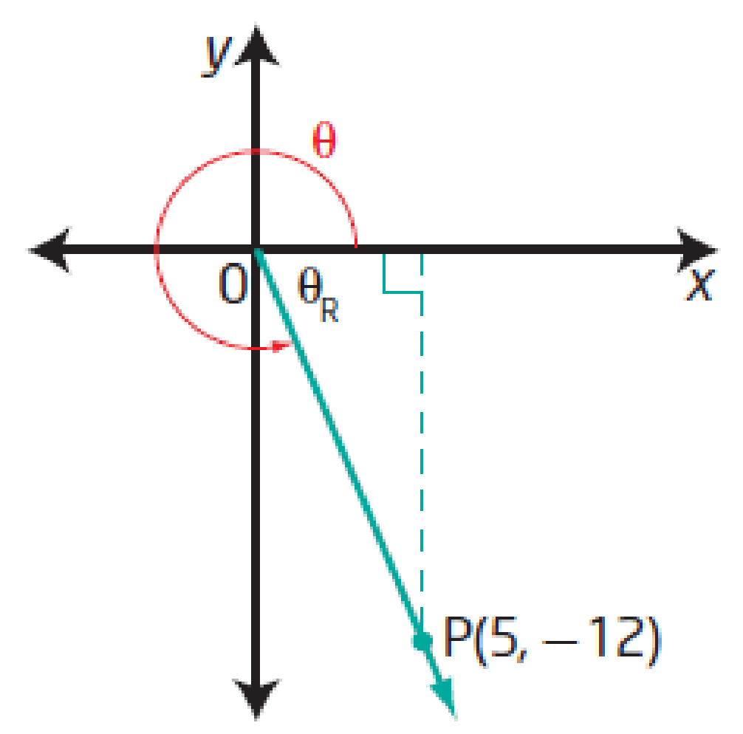a) b) 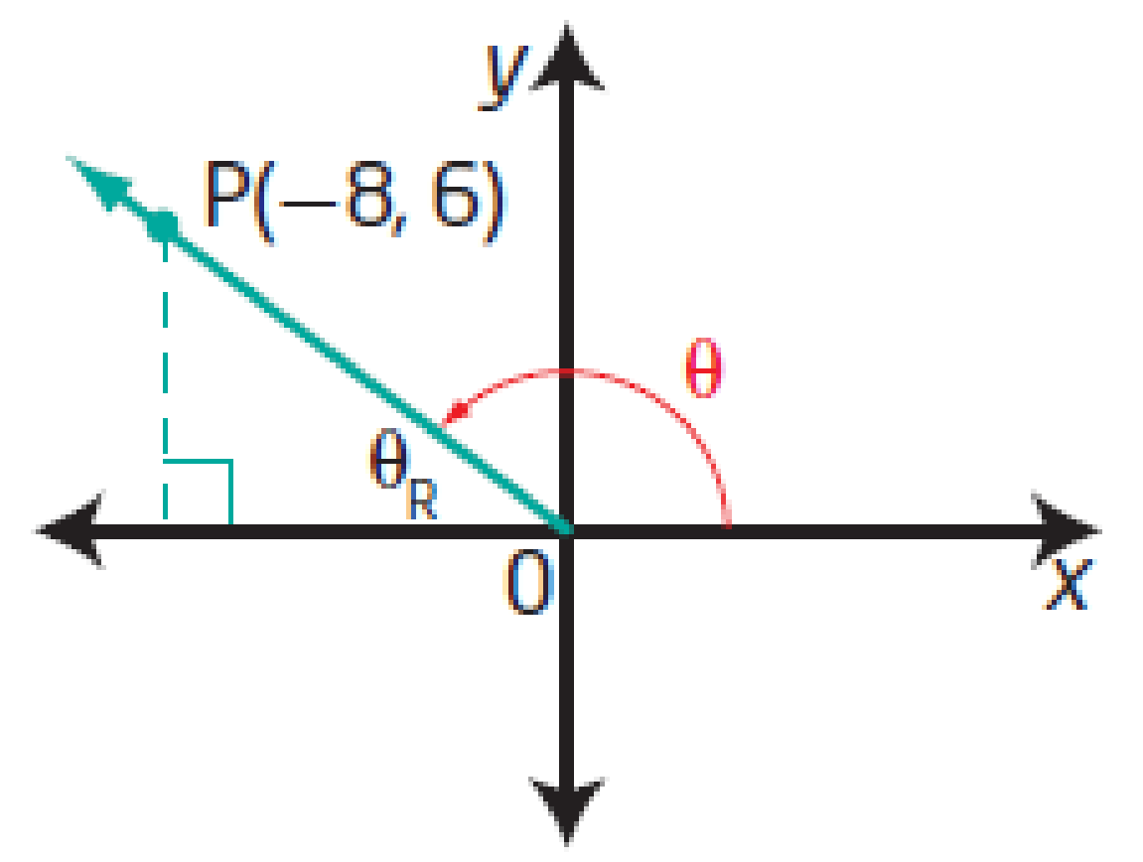

5. For each description, in which quadrant does the terminal arm of angle θ lie? **HINT:** Use the CAST rule.

a) cos θ < 0 and sin θ > 0 b) cos θ > 0 and tan θ > 0

c) sin θ < 0 and cos θ < 0 d) tan θ < 0 and cos θ > 0

6. a) Determine sin θ when the terminal arm of an angle in standard position passes through the point P(2, 4).

1. Extend the terminal arm to include the point Q(4, 8). Determine sin θ for the angle in standard position whose terminal arm passes through point Q.
2. Extend the terminal arm to include the point R(8, 16). Determine sin θ for the angle in standard position whose terminal arm passes through point R.

d) Explain your results from parts a), b), and c). What do you notice? Why does this happen?

Discovering Properties of Special Right Triangles

There are two types of special right triangles, both defined by their angles. The first is a 45o – 45o – 90o and the second is a 30o – 60o – 90o.

**Part A: 45o – 45o – 90o Triangles**

Before you begin, how would you classify a 45o – 45o – 90o triangle by its sides?

(a) scalene (b) isosceles (c) equilateral

Now to begin: You’re looking for an easy way to find the length of the sides in these triangles. **Your goal is to avoid using the Pythagorean theorem**, but in order to do that you must first use the theorem and see if you notice a pattern.

Find the lengths of the missing sides. Leave all of your answers in reduced radical form. (For example: )

1) 2) 3)

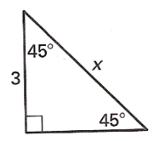 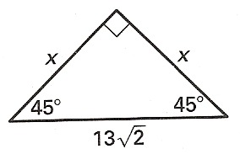 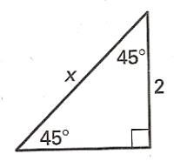

4) 5) 6)

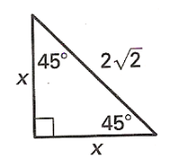 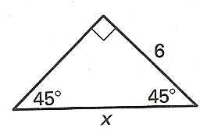 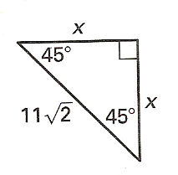

Write a conjecture that describes what you see:

Test your conjecture on these triangles.

1) 2) 3)

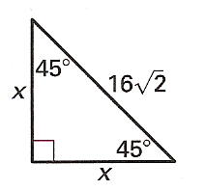 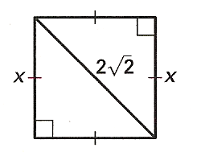 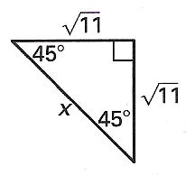

**Part B: 30o – 60o – 90o Triangles**

This time, you’re looking for an easy way to find the length of the sides in 30o – 60o – 90o triangles.

Again, your goal is to avoid using the Pythagorean theorem, but in order to do that you must first use the theorem and see if you notice a pattern.

And again, please leave all of your answers in reduced radical form.

**We’ll start with equilateral triangles and three questions:**

1. What do the angles in an equilateral triangle measure?
2. When you draw the altitude in an equilateral triangle, what does it do to the top angle?
3. When you draw the altitude in an equilateral triangle, what does it do to the base?

**Now to begin: Find the length of the altitude in these equilateral triangles (sketch the triangle if it helps)**

1) sides = 6 cm 2) sides = 10 cm 3) sides = 200 cm

**How does the altitude compare to half of the base?**

When you draw the altitude in an equilateral triangle, you create two congruent 30o – 60o – 90o triangles. The two legs of each triangle are called “shorter leg” and “longer leg” (doh!).

**So using what you determined before, how does the longer leg in a 30o – 60o – 90o triangle compare to the shorter leg?**

Length of longer leg = ____________ * Length of shorter leg

**And how does the hypotenuse (the sides of your equilateral triangles) compare to the shorter leg?**

Length of hypotenuse = ____________ * Length of shorter leg

**Test your results on these triangles.**

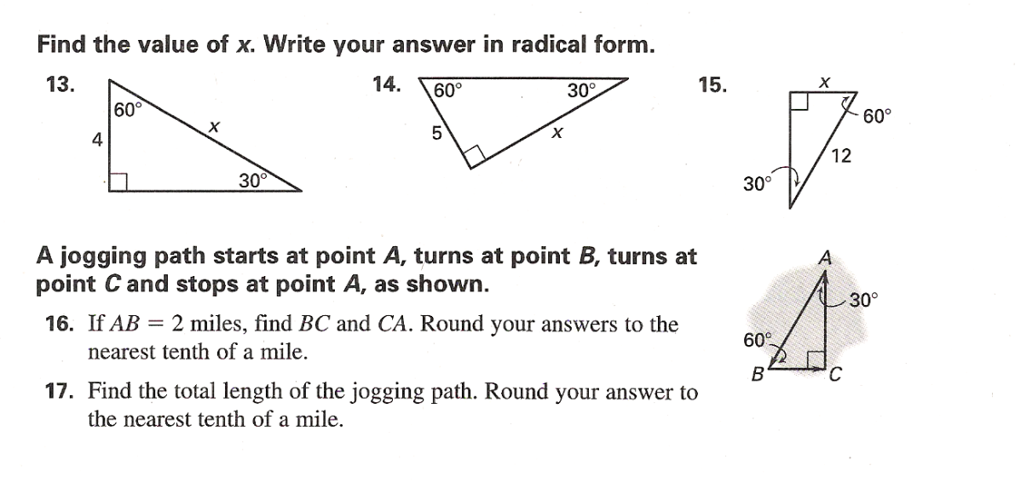

**Algebraic Solving of Systems of Equations**

***Four corners are cut from a rectangular piece of cardboard that measures 5 ft by 3 ft. The cuts are x feet from the corners, as shown in the figure below. After the cuts are made, the sides of the rectangle are folded to form an open box. The area of the bottom of the box is 12 ft2.***



**What two equations represent the area, *A*, of the bottom of the box?**

|  |  |  |  |
| --- | --- | --- | --- |
| **A** |  | **C** |  |
| **B** |  | **D** |  |

**What are the approximate dimensions of the box? Give your answer to one decimal place.**

|  |  |  |  |
| --- | --- | --- | --- |
| **A** | width = 2.6 ft  length = 4.6 ft  height = 3.8 ft | **C** | width = 4.8 ft  length = 2.8 ft  height = 0.1 ft |
| **B** | width = 4.0 ft  length = 2.0 ft  height = 0.5 ft | **D** | width = 4.6 ft  length = 2.6 ft  height = 0.2 ft |

**What is the approximate volume of the box? Give your answer to one decimal place.**

|  |  |  |  |
| --- | --- | --- | --- |
| **A** | 1.4 ft3 | **C** | 2.4 ft3 |
| **B** | 4.0 ft3 | **D** | 45.6 ft3 |

**Solve each system of equations by using *substitution*. If there is no solution, put Ø.  If it is the same line, write {(x,y): equation of the line}**

**y = 3x + 4 3x – 3y = 15 5x + 6y = 32**

**4x + 2y = 18       x  = 1 + 2y     12y – 4x = 8**

**Use *elimination* to solve the systems of equations.  If there is no solution, put Ø.  If it is the same line, write {(x,y): equation of the line}**

**x – 2y = 4 x + 3y = 18 4x – 3y = 22**

**y = x – 2   -x + 2y = 7     2x + 8y = 30**

**Solve the system of equations by elimination and by substitution.**

** and **

**What are the coordinates of the point(s) of intersection of the line  and the quadratic function ? Solve algebraically.**

**What are the solutions for the following system of equations? Solve algebraically.**





**Solving Inequalities & Graphing Solution on a Number Line**

**Sketch the graph of each quadratic inequality. Use a test point to determine shading.**

a)  b) 

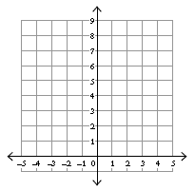 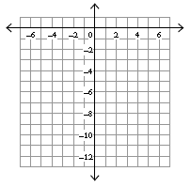

c)  d) 

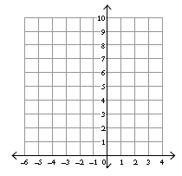 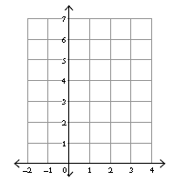

**Write an inequality for each graph given the equation for the boundary function. (Change the = sign to >, < >, or < to write the inequality. You will want to use a test point to decide which side to shade.**

a)  b) 

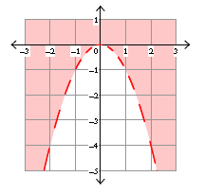 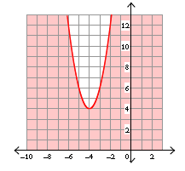

**Does the given value of *x* make the inequality a true or a false statement?**

 *x* = 2 **TRUE** or **FALSE**

**Sketch the graph of each linear inequality. Use a test point to determine shading.**

a)  b) 

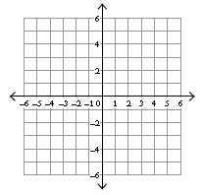 

c)  d) 

 

**Write the inequality for each graph.**

a) b)

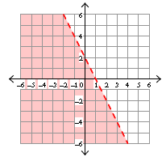 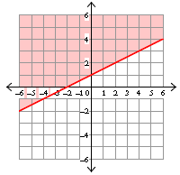

**Solve: **

(a) How many x-intercepts are there for ? If there are any x-intercepts, where are they?  
  
  
  
(b) Does the parabola (when graphed) open: UPWARDS or DOWNWARDS?

(c) Draw a general schematic diagram of what’s going on:

*x-axis*

(d) Answer the question: 

{*x*| , *x* E R}

**8. Which number line represents the solution set to the inequality ?**

|  |  |  |  |
| --- | --- | --- | --- |
| **A** |  | **C** |  |
| **B** |  | **D** |  |

**Which graph represents the solution to the inequality ?**

|  |  |  |  |
| --- | --- | --- | --- |
| **A** |  | **C** |  |
| **B** |  | **D** |  |

**The solution set to the inequality  is**

|  |  |  |  |
| --- | --- | --- | --- |
| **A** |  | **C** |  |
| **B** |  | **D** |  |